**Auto Format**

To automatically format code in Netbeans select the code you wish to format. Then hit the

Alt + Shift + F in Windows/Linux

Ctrl + Shift + F in Mac

Windows

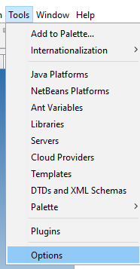Regular auto format will cover most whitespace and alignment requirements. Auto format settings can be changed to cover more by taking the following steps:

1. Select Tools -> Options

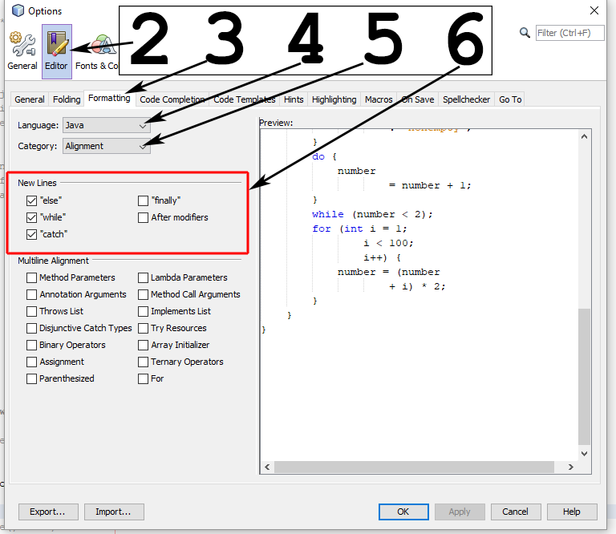

1. Select the **Editor** option
2. Select the **Formatting** tab
3. Make sure the Language is set to **Java**
4. Make sure the Category is set to **Alignment**
5. Check else, while, and catch

Mac

1. Select Netbeans -> Preferences
2. 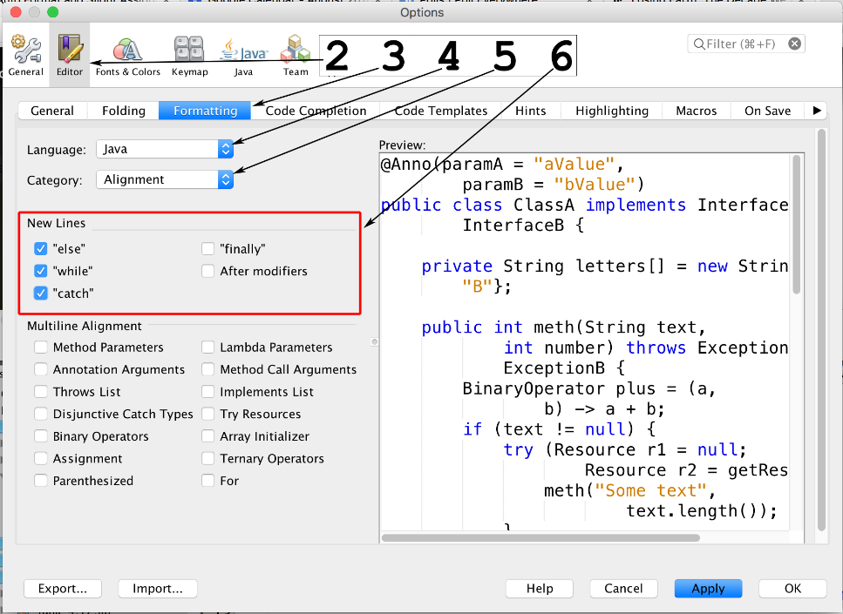Select the **Formatting** option
3. Make sure the Language is set to **Java**
4. Make sure the Category is set to **Alignment**
5. Check else, while, and catch